**CSE320: Data Communications**

**Quiz-03 (Set – A)**

**Total Marks: 20**

**Name: ID: Sec:**

1. For the following Multi-level ASK, find the bit stream form the signal below: [4]

|  |  |  |  |  |  |  |  |  |  |  |  |
| --- | --- | --- | --- | --- | --- | --- | --- | --- | --- | --- | --- |
| |  |  | | --- | --- | | Bit Pattern | Amplitude | | 00 | 3V | | 01 | 4V | | 10 | 0V | | 11 | 1V | |  |

2. Draw the analog signal for the digital bit stream 110100101011 using Multi-level FSK where 2 bits at a time get transmitted. [Amplitude of the Carrier Signal = 2V and phase = 0 rad, Number of Cycles of the signal element for different Bit Patterns: 00- 4, 01- 2, 10- 3, 11- 1] [4]

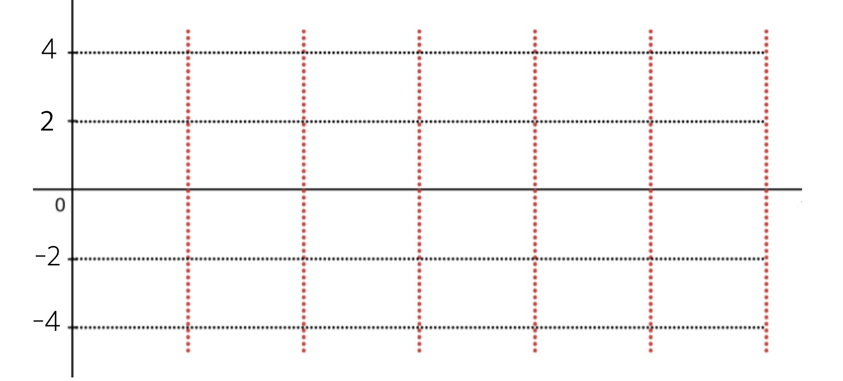

3. Draw the analog signal for the bit stream 1011001011 using the constellation diagram given below [frequency = 2 for each signal element and amplitude = 6V] [4]

|  |  |
| --- | --- |
|  |  |

4. Why PSK is superior to FSK? [4]

5. What is coherent FSK and non-coherent FSK? Explain. [4]